**TERM WORK – IV**

**INSURANCE DATABASE**

**Consider the Insurance database:**

**Car (regno:string, model:string, year:number)**

**Person (driver_id:string, fname:string, lname:string, address:string, rno:string)**

**Accident (reportno:number, accdate:date, location:string)**

**Participated (did:string, reg:string, repno:number, damt:decimal)**

1. Draw ER and Schema Diagram
2. Create above tables by properly specifying primary and foreign keys.
3. Insert at least 5 values to all tables.
4. Update the amount to 12000 for report number 114.
5. Retrieve the detail of Car model, Year, Person name.
6. Retrieve the detail of accidents from the year 2021.
7. Count the number of accidents from the year 2021.
8. Retrieve repno, model, person name, location and damage amount.
9. Delete report number 113.
10. Create view on person for driverid, fname, lname.
11. Draw ER and Schema Diagram.

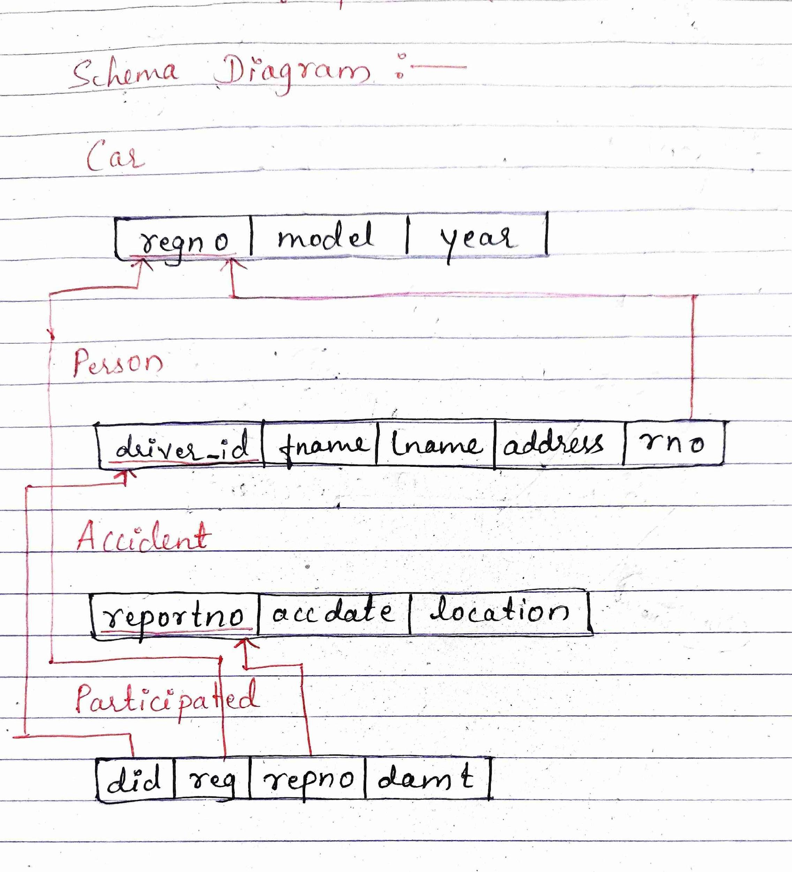

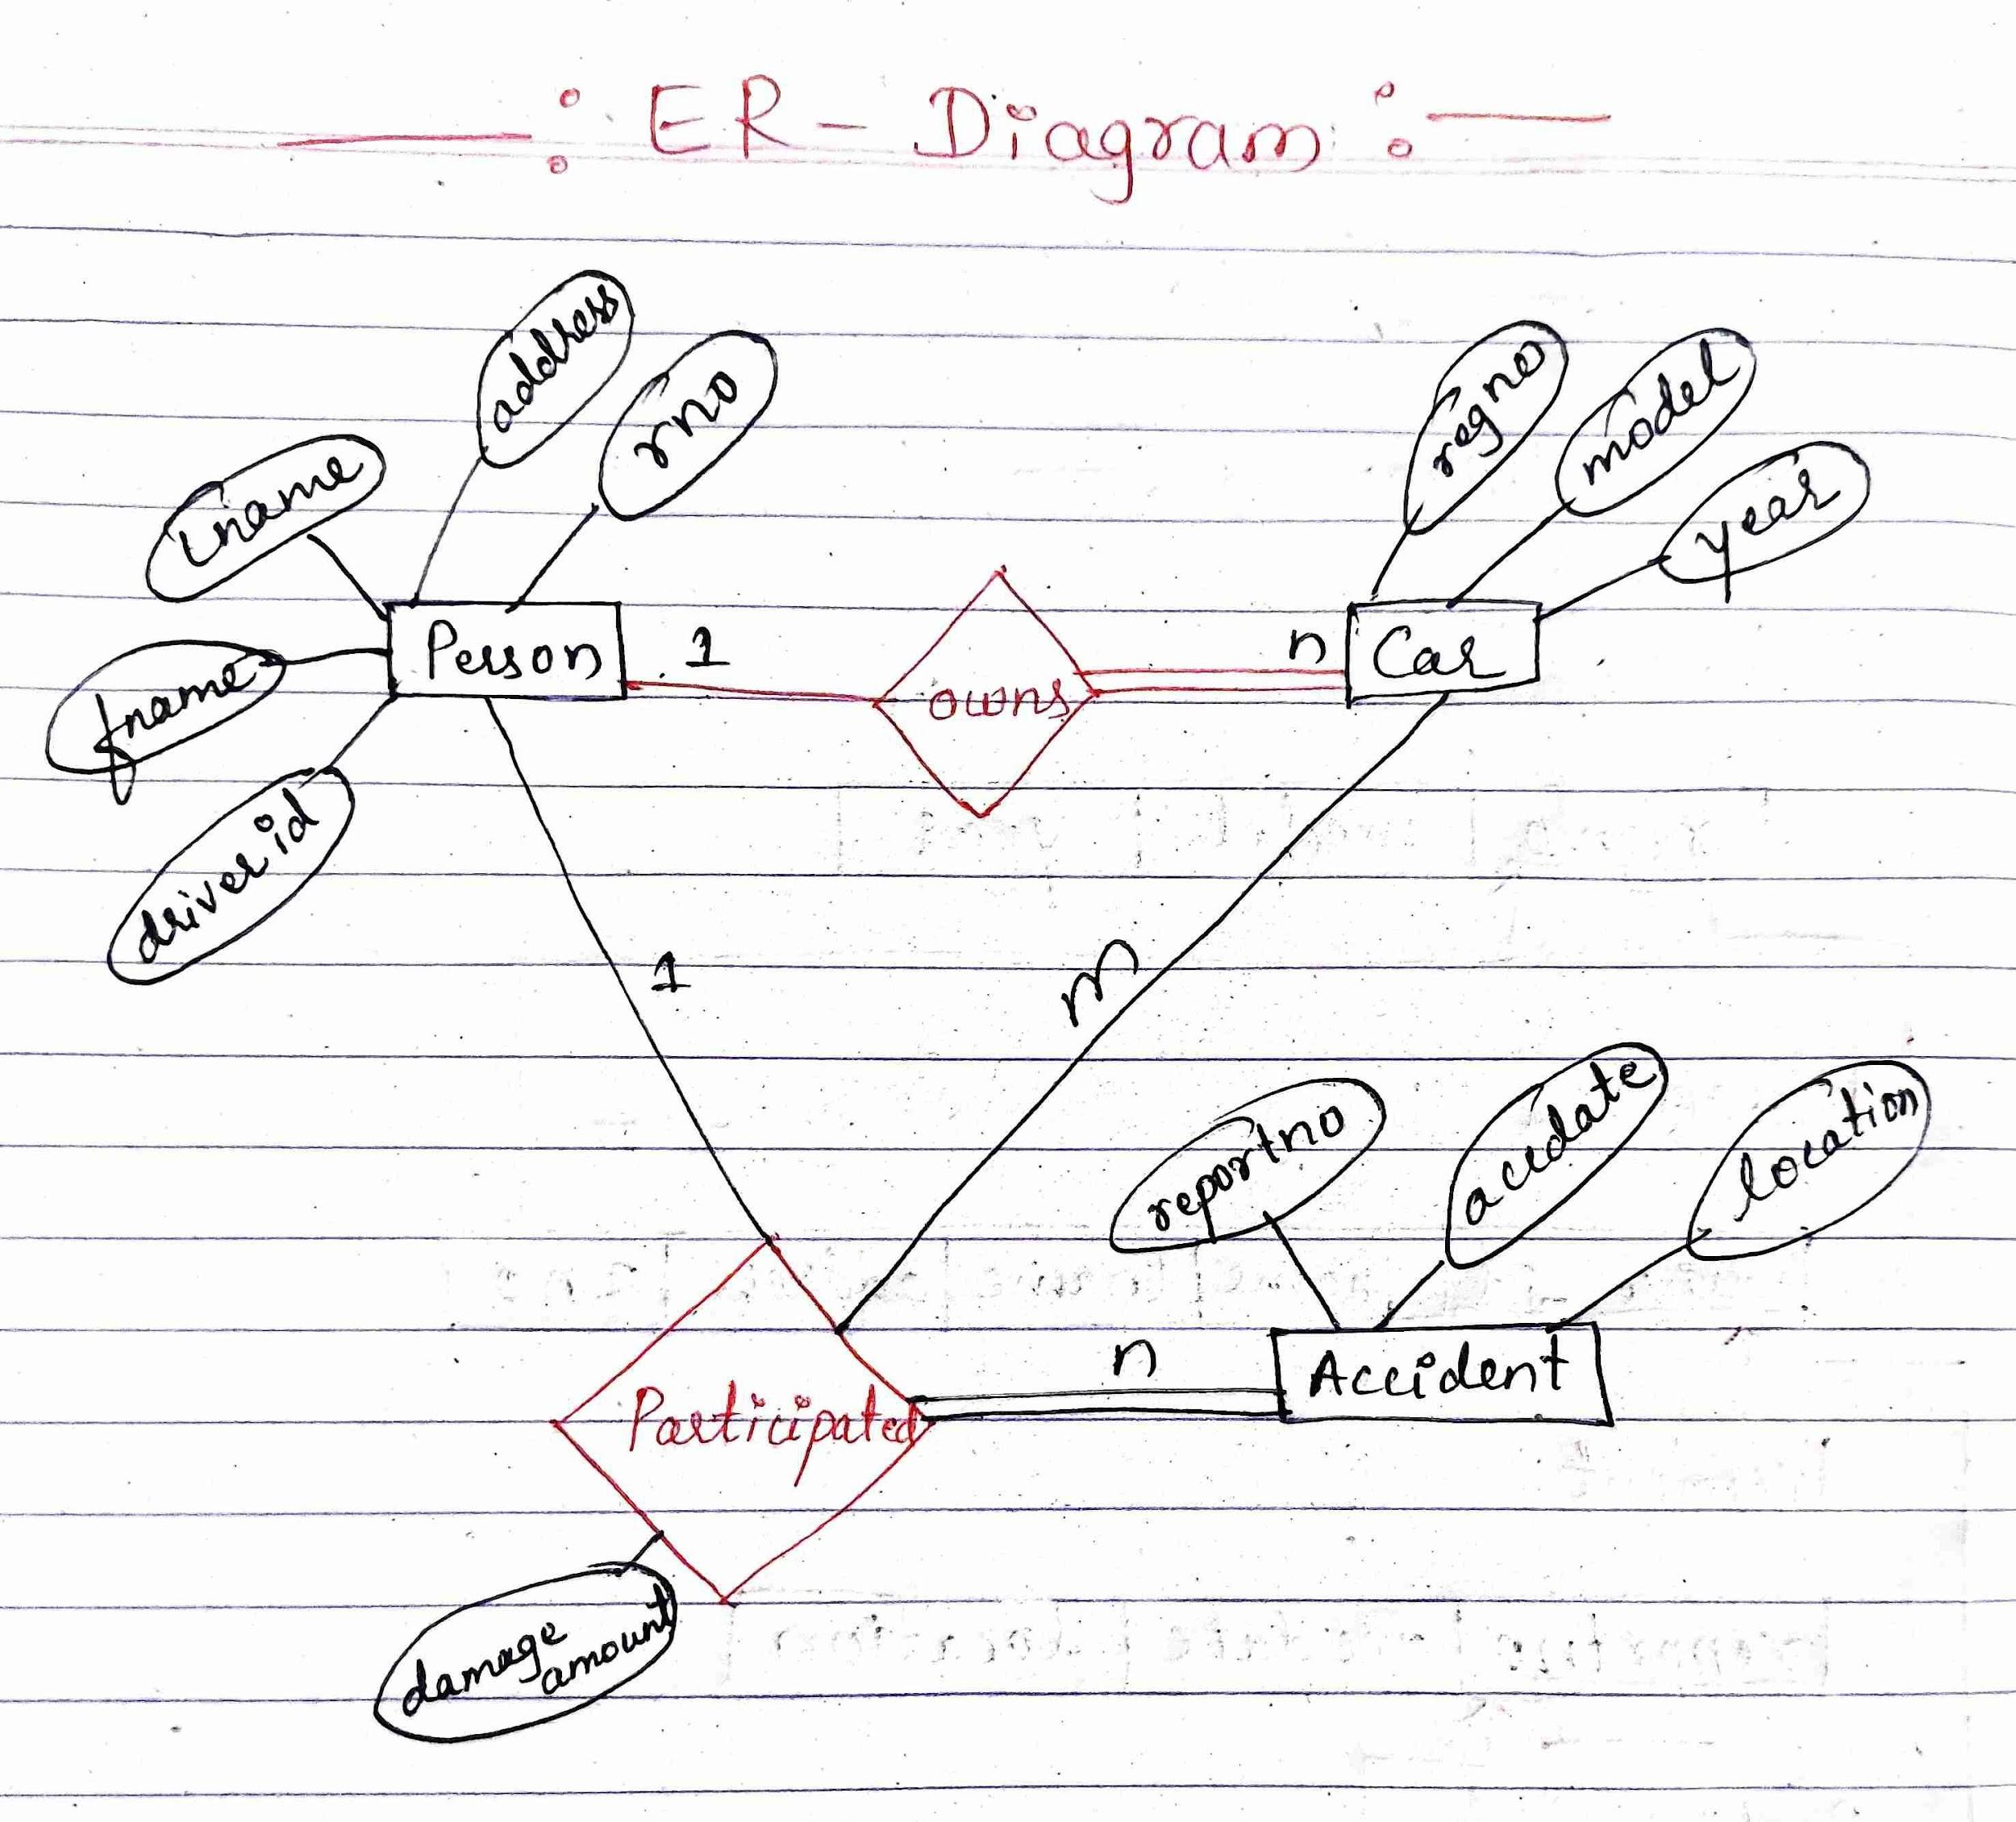

2. Create above tables by properly specifying primary and foreign keys.

3. Insert at least 5 values to all tables.

create table carsw

(

regno varchar(10) primary key,

model varchar(15) not null,

year number(4)

);

Insert into carsw values('KA001','Nano',1995);

Insert into carsw values('KA002','ALTO',1990);

Insert into carsw values('KA003','INNOVA',2015);

Insert into carsw values('KA004','INNOVA PLUS',2015);

Insert into carsw values('KA005','KIYA',2020);

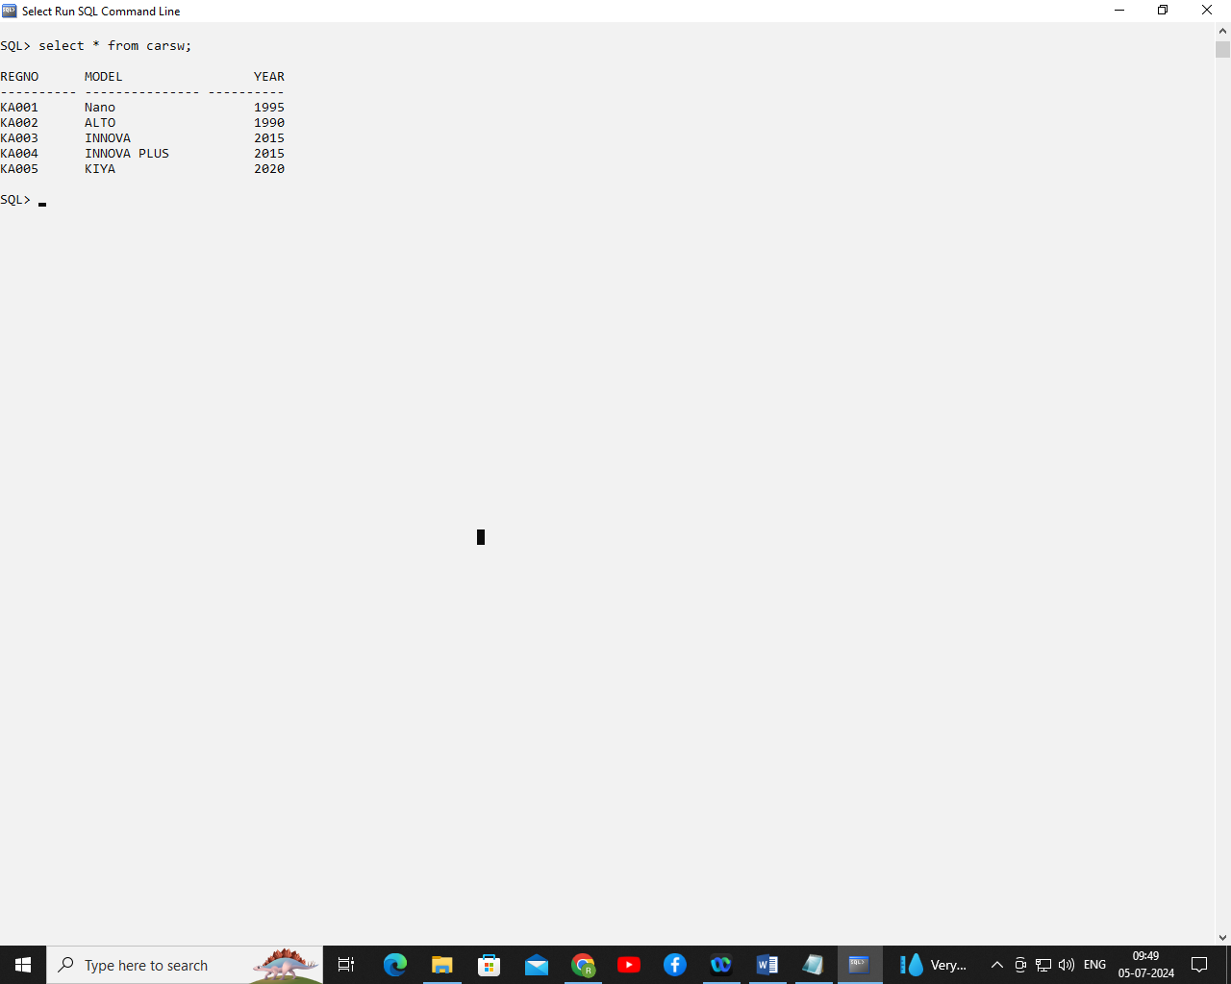

create table personsw

(

driver_id varchar(10) primary key,

Fname varchar(15) not null,

Lname varchar(15),

address varchar(50),

rno varchar(10),

foreign key (rno) references carsw(regno)

);

insert into personsw values('D001','Amit','Kumar','Goa Ves Belagavi','KA004');

insert into personsw values('D002','Suvarna','Singh','Angol','KA003');

insert into personsw values('D003','Deepak','Kulkarni','Tilakwadi','KA002');

insert into personsw values('D004','Akshata','Patil','Near Ramdev Belagavi','KA001');

insert into personsw values('D005','Manish','Desai','Third Gate Belagavi','KA005');

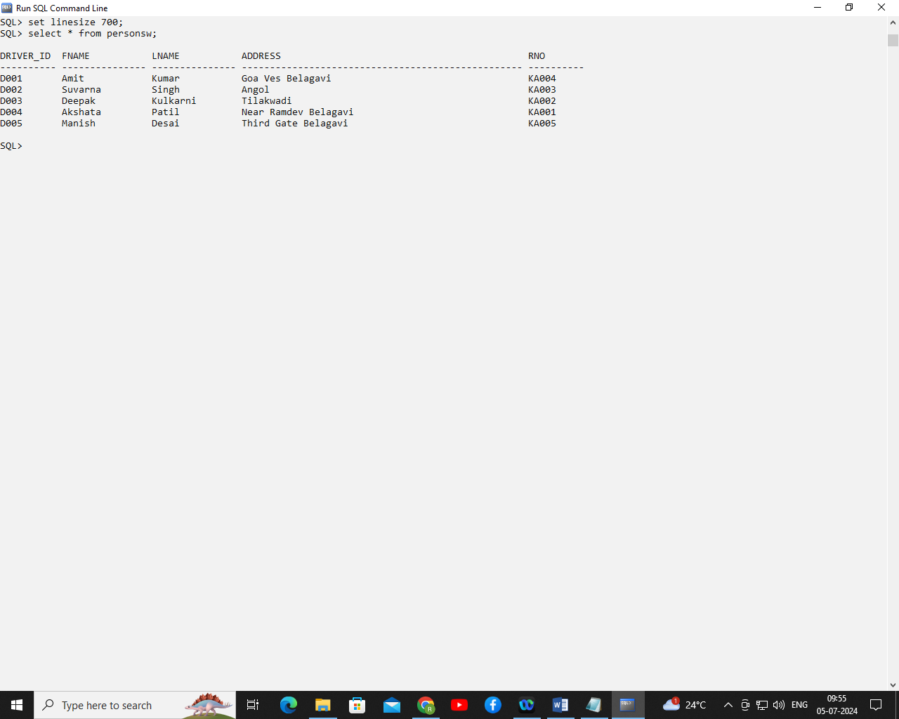

create table accidentsw

(

reportno number(5) primary key,

accdate date,

location varchar(30)

);

Table created.

insert into accidentsw values(111,'03-Jan-2000','Bogar ves');

insert into accidentsw values(112,'06-Aug-2000','College ROad');

insert into accidentsw values(113,'07-June-2021','Bogar ves');

insert into accidentsw values(114,'09-nov-21','JNMC ROad');

insert into accidentsw values(115,'09-nov-21','Goa ves');

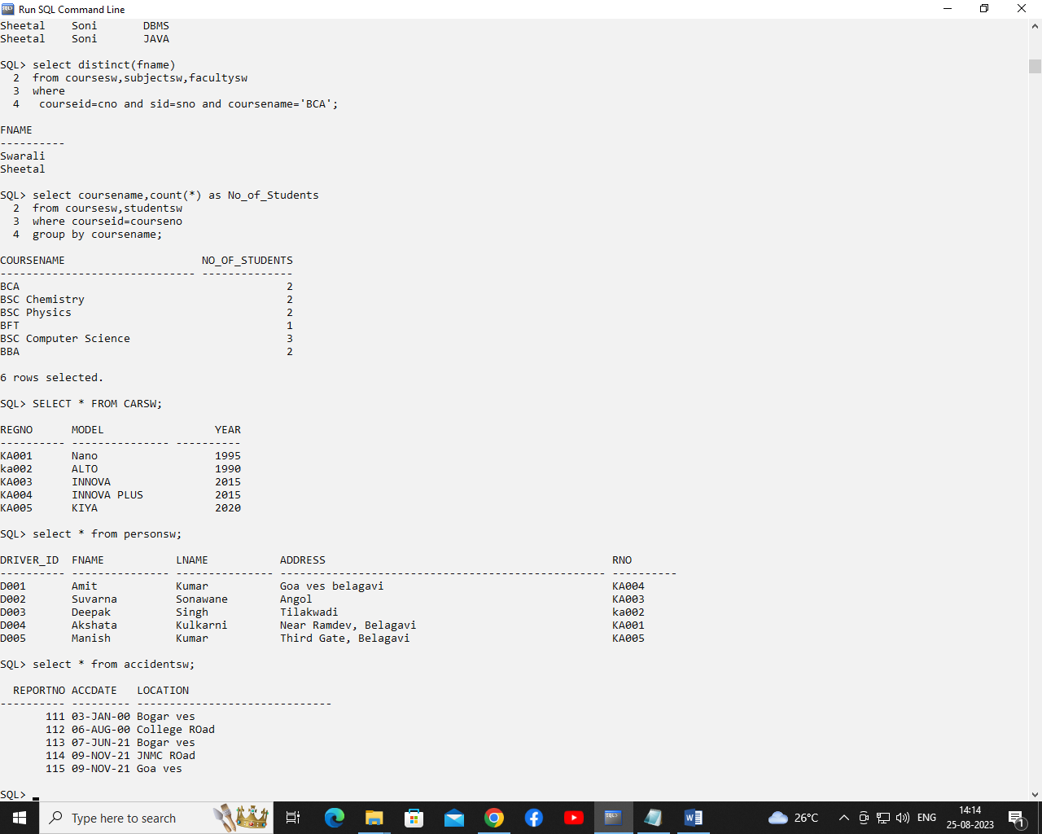

create table participatedsw

(

did varchar(10),

reg varchar(10),

repno number(5),

damt decimal(10,2),

foreign key (did ) references personsw(driver_id),

foreign key (reg ) references carsw(regno),

foreign key (repno) references accidentsw(reportno)

);

insert into participatedsw values('D002','KA002',111,25000);

insert into participatedsw values('D001','KA001',112,30000);

insert into participatedsw values('D003','KA005',115,50000);

insert into participatedsw values('D003','KA002',114,2000);

insert into participatedsw values('D004','KA002',113,60000);

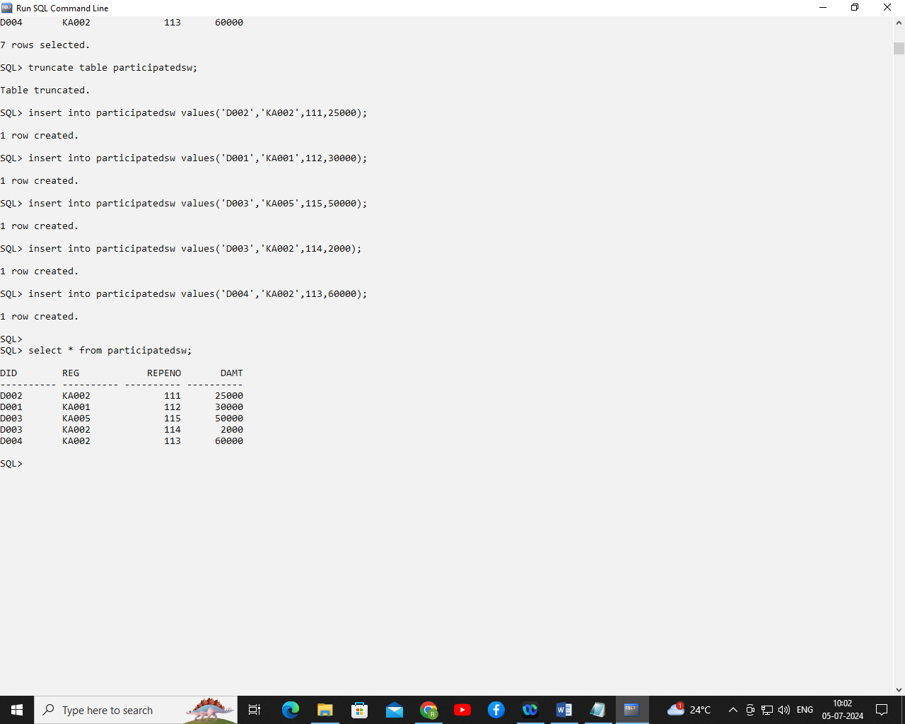

4. Update the amount to 12000 for report number 114.



update participatedsw set damt=12000 where repno=114;

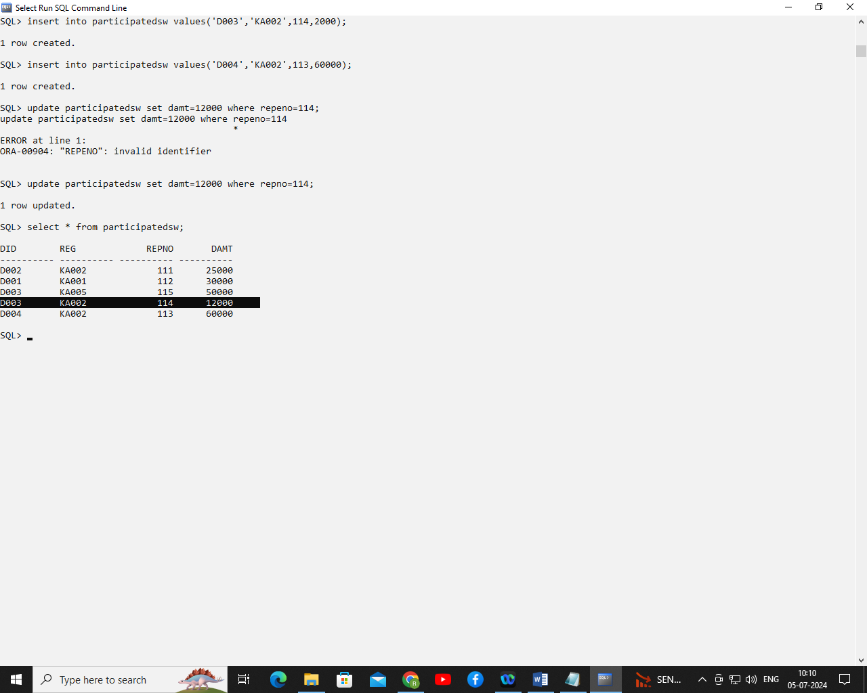

5. Retrieve the detail of Car model, Year, Person name.

Select model,year,fname,lname

From carsw c, personsw p

Where c.regno=p.rno;

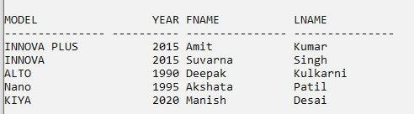

6. Retrieve the detail of accidents from the year 2021.

select * from accidentsw where accdate like '%21';

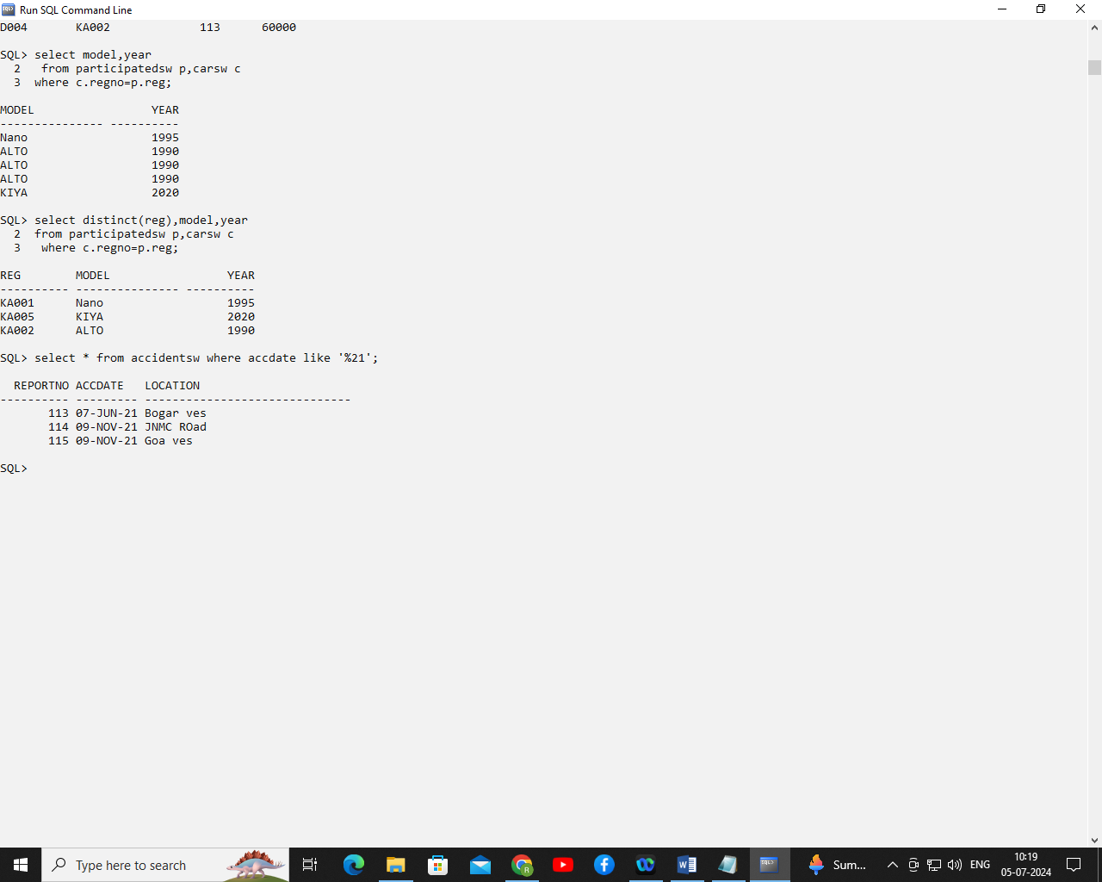

7. Count the number of accidents from the year 2021.

select count(*) from accidentsw where accdate like '%21';

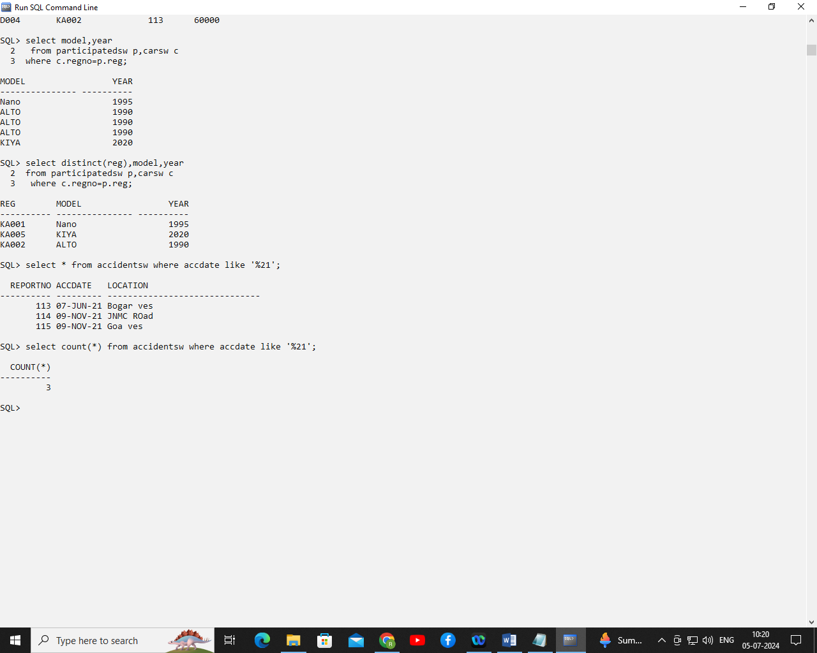

1. Retrieve repno, model, person name, location and damage amount.

select repno,model,fname,lname,location,damt

from personsw p,carsw c,accidentsw a,participatedsw pt

where pt.did=p.driver_id and

pt.reg=c.regno and

pt.repno=a.reportno;

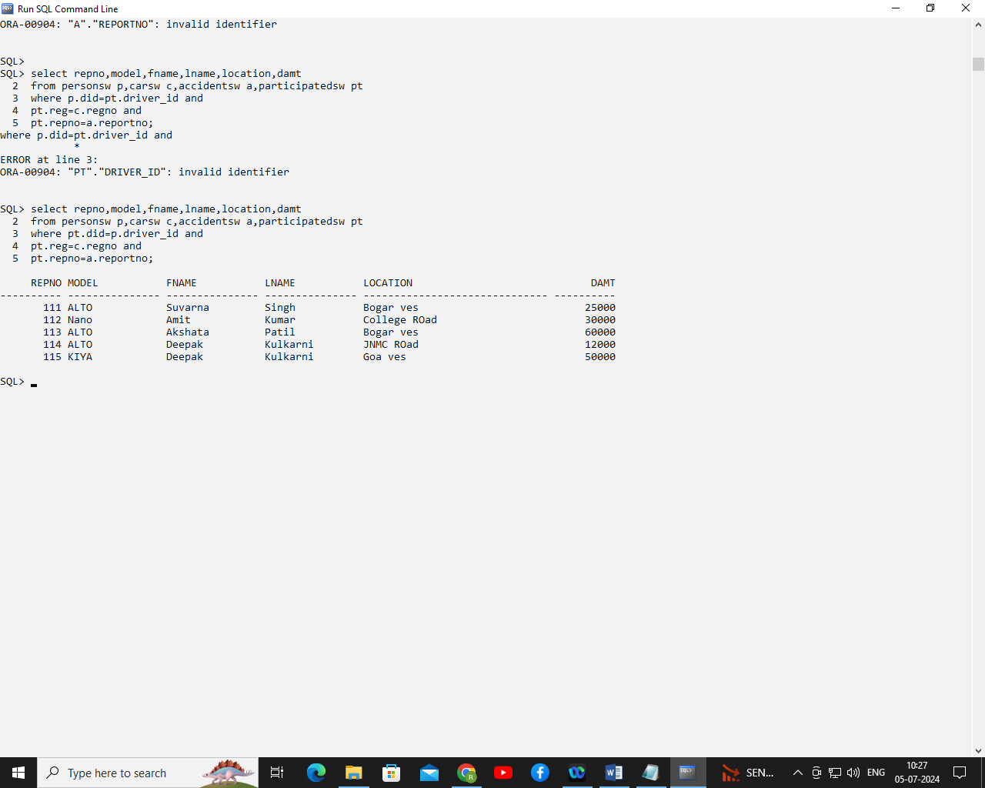

1. Delete report number 113.

Delete from participatedsw where repno=113;

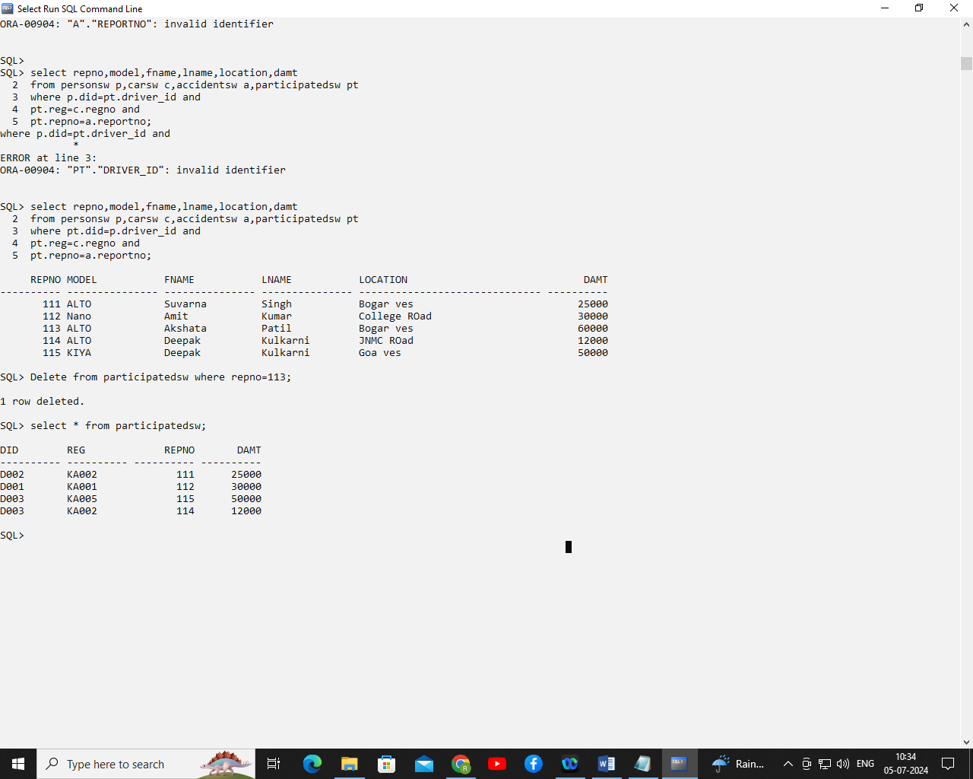

delete from accidentsw where reportno=113;

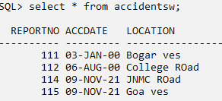

1. Create view on person for driverid,fname,lname

create view person_details as select driver_id,fname,lname from personsw;

select * from person_details;

